Planning your procurement

Lesson 1 of 7
Our best practice procurement methodology
In the simplest of terms, goods and services procurement involves:
- planning to determine needs and define the right strategy
- sourcing the right suppliers to provide goods or services
- managing the rights and responsibilities of all parties involved
- disposing of goods when they are no longer required, where applicable.
Best practice
Procurement best practice follows three stages: planning, sourcing and managing; each with three steps.
Select the items below to learn more
Stage 1 – Planning
The planning stage of a procurement involves engaging with stakeholders to identify their needs, conducting market research and forming a procurement strategy.
Stage 2 – Sourcing
The sourcing stage includes approaching the market, evaluating offers, negotiating and awarding a contract.
Stage 3 – Managing
Signing a contract is not the end of the process. It’s the start of an on-going relationship with the supplier to ensure you get what you contracted for.
This includes monitoring supplier performance, reporting, ensuring the supplier is paid and acting as a point of contact if any issues arise.
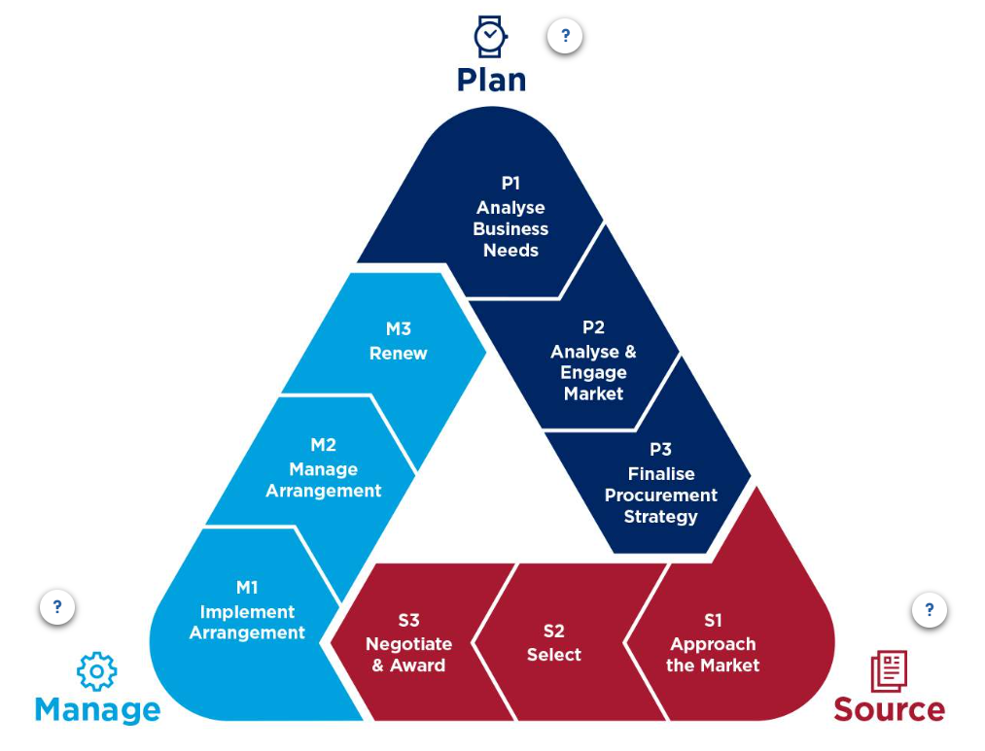
Lesson 2 of 7
The planning stage

Investing effort in planning directly contributes to better procurement outcomes. It helps ensure value for money, reduces risks and increases opportunities for sustainable procurement and innovation
Michelle Robinson - Manager Supplier Excellence
Many procurements that have issues during the Manage stage arise because of poor planning. Even simple procurements require some basic planning prior to conducting the purchase. The effort you put into planning should be proportionate to the size, value and complexity of your procurement.
Low value, simple purchases are less likely to need elaborate planning, as is the case with more complex purchases. However, a degree of effort is always required to:
- understand the business need
- analyse the supply market
- consider your options
- plan the procurement.

Lesson 3 of 7
Analyse the business need
Getting a good understanding of what is really needed is critical for ensuring that the goods or services you procure are fit for purpose and achieve value for money.
Considering things like quantity, capability, cost, timing and quality can help you to plan a procurement that will satisfy the business need.
Engage your stakeholders
At the start of your procurement project, you'll need to engage your stakeholders to understand their needs and win their commitment to your procurement strategy.
Stakeholders are people or organisations with an interest in the procurement because it affects them in some way or you need their support.
Identify your stakeholders
Consider who your stakeholders are - are they internal or external?
Involve your stakeholders
Involve them early to help inform, improve and shape your procurement planning.
Understand your stakeholders
Identify any concerns they may have about the procurement and consider how they could positively or negatively influence your procurement.
Define the business need
Demand for goods or services can be initiated in several ways, including verbal or written, from a variety of stakeholders.
It's common for stakeholders to produce a long list of things they want, rather than what they need to address the problem.
When defining the business need you should:
- consider the requirements - both current and future requirements
- explore ideas and alternatives for delivering the same outcome
- define the business need so that potential suppliers can clearly understand the requirement
- seek agreement from your stakeholders.

Exploring alternatives
When considering alternative options, think about:
- challenging the demand - are the goods and services really needed?
- alternative methods of meeting the demand
- reducing the frequency of use
- reusing or recycling
- simplifying and/or standardising specifications
- reducing the product and services range and complexity.
Lesson 4 of 7
Analyse the market
Market analysis is about understanding how the market for particular goods or services works. Without this information, it can be difficult to decide on the best way to approach the market or to assess the risks associated with your procurement.
Analysing the market can help you to understand:
• Typical prices
• Size of the market
• Who the key suppliers are, and their location
• How competitive the market is
• Alternative goods and services
• Market trends
• New and innovative solutions
• Suppliers' capability and capacity to deliver
• Solutions implemented by other agencies
• Your agency's buying power
Ways to analyse the market
When analysing the market you should:
Step 1
Consider existing procurement arrangements

First, check if the goods or services are available on an existing procurement arrangement.
Note: Check the Governance topic of this course or visit Government procurement arrangements(opens in a new tab) on buy NSW to learn about existing procurement arrangements.
Step 2
Identify suppliers
You can identify suppliers for specific goods and services from the Supplier hub(opens in a new tab), including:
- local businesses
- small and medium enterprises (SME)
- regional businesses
- Aboriginal businesses
- social enterprises.
Registration(opens in a new tab) is required to view supplier profiles and products.
When suppliers join Supplier Hub, they are given the option to add business identifiers. These will be self-identified (Blue) or verified through a third party (Green). For example, you can be a verified aboriginal owned business, disability employment organisation, a verified social enterprise or gender equitable employer.
Step 3
Gather information about goods and services
Request information from suppliers about their goods and services, including checking their websites and marketing materials. You may also arrange for demonstrations.
This is also a good opportunity to inquire about suppliers' sustainable procurement methods.
Step 4
Consider researching customer reviews, comparison sites and industry bodies/experts to learn more about suppliers and their goods and services.
Step 5
Learn from others
Check if another agency has procured something similar and seek their advice and lessons learned.
Supplier due diligence
Supplier due diligence refers to the checks you perform on potential suppliers to understand if they:
- are genuine
- are capable and reliable
- are financially viable
- have the required authorities, licences and status
- are of good repute and integrity.
While most due diligence tasks are performed during the sourcing stage (after potential suppliers have been identified), it is important to consider when planning your procurement. This includes:
- identifying the capabilities that will be required to fulfil the procurement
- understanding the regulatory environment that applies to suppliers in the market
- deciding how to approach the market, what information suppliers will need to provide and how this information will be verified.
You should include due diligence measures in your procurement strategy and market-facing documents.
Check the Independent Commission Against Corruption's (ICAC) Supplier Due Diligence guide(opens in a new tab) for more information, including specific guidance on the checks you can make.
Learn more about supplier due diligence checks
Complete the Supplier due diligence module (opens in a new tab)as part of the Procurement Skills Booster training.
Lesson 5 of 7
Finalise your procurement strategy
To be successful, you should develop a strategy that considers your business needs, the market, risks and opportunities. Obtaining approval for the expenditure is critically important.
Note: For low value, low risk procurements and simple purchases, a Briefing Note or email approval may be used as the procurement strategy. Check with your agency’s procurement team.
What to consider in your strategy
When developing your procurement strategy consider:
Need and why? What are the benefits? Will it deliver environmental, social or economic outcomes?
What's the total estimated contract value?
What does the supply market look like?
Are there any existing contracts or schemes that you should use?
Should your procurement be preferencing certain types of suppliers? Does your procurement qualify for exemptions?
What risks are you facing and how will you manage them?
What type of market approach will you use and why?
What will success look like?
Timings - When do: existing arrangements conclude? you need to release the market documents?
Finalising your strategy
To finalise your procurement strategy:
Step 1
Summarise your key findings
Summarise your key findings on:
- the business needs
- your market analysis
- risks and opportunities.
Step 2
Include key procurement details
Include the total estimated contract value and contract period, including any extensions, and your strategy for approaching the market.
Step 3
List the benefits
Identify the benefits of the procurement outcome.
Step 4
Gain buy-in
Make sure you have enough support for the strategy from your stakeholders.
Step 5
Get approval
Get approval from your manager, director or agency head, as per your agency’s financial delegations.

Lesson 7 of 7
Summary
Key Takeaways
- Procurement best practice has three stages: planning, sourcing and managing; each with three steps.
- The effort you put into planning should be proportionate to the size, value and complexity of your procurement.
- To deliver a successful procurement outcome you'll need to engage your stakeholders early to understand the business need and get their buy-in.
- Analysing the market will help you to understand how the market works and decide on the best way to approach the market and address any risks.
Develop a strategy that considers your business needs, the market, risks and opportunities, and ensure you get approval.

